**How Does He Saw Me?**

[A Recommendation Engine for Picking Heroes in Dota2](http://cs229.stanford.edu/proj2013/PerryConley-HowDoesHeSawMeARecommendationEngineForPickingHeroesInDota2.pdf)

**Objective:** This paper wants to provide a recommendation engine built on machine learning algorithms.

**Introduction:** Each Dota2 game consists of two teams of five players pitted against each other. *An interesting aspect of the game is that in choosing a hero, players must keep in mind not only the individual strengths and weaknesses of each hero, but also how the strengths and weaknesses of that hero interact with the heroes already chosen by other players.* Thus, an effective hero pick is one that synergizes with the heroes chosen by teammates, and both exploits the weaknesses and minimizes the strengths of the heroes chosen by the opposing team. An aim of this project is to recommend that will perform well against opposing team.

**Algorithm:** By applying logistic regression and K-nearest neighbor models to these challenges and this paper achieves promising results.

* **Logistic Regression:** Firstly, algorithm reads, learns from a curve and makes analysis of data from 90% of 56691 played games, where 10% these games used for testing.
* **K-Nearest Neighbors:** K-nearest neighbors is a non-parametric method for classification and regression that predicts objects’ class memberships based on the k-closest training examples in the feature space.

**Calculating Weights:**

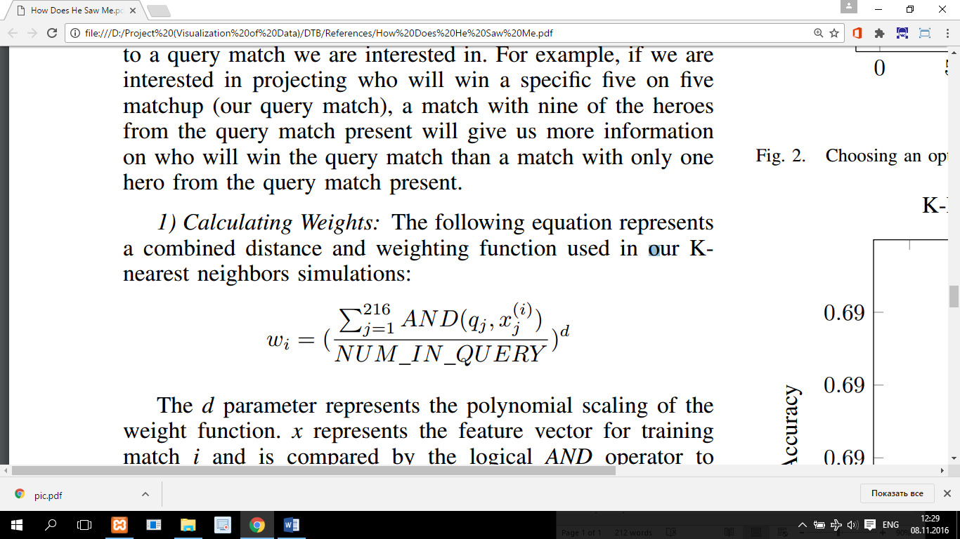

d parameter represents scaling of the weight function. x represents the feature vector for training match I and is compared by logical AND operator to query vector q. NUM_IN_QUERY represent the number of heroes in the query vector. A larger d will result in similar matches getting much more weight than dissimilar matches.

**Sample Result:**

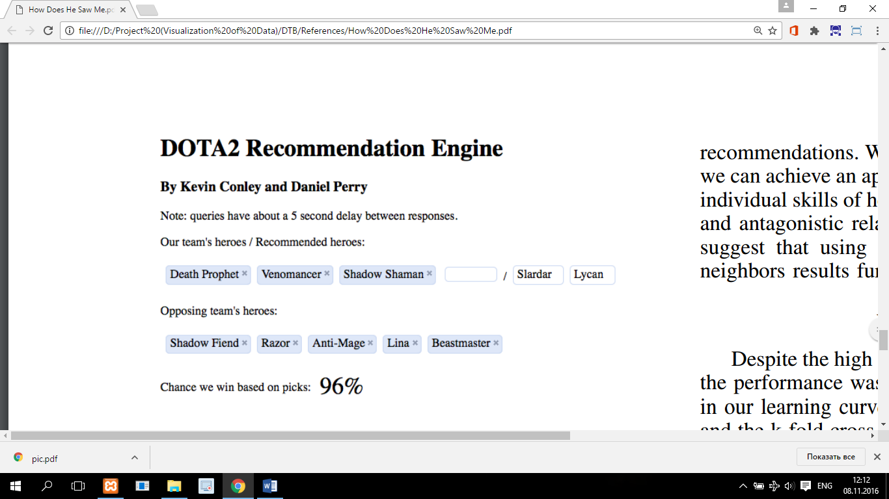

**Conclusion:**

This paper is most closely related to my term project’s data computing part and I will try to extend this paper to determine most optimal heroes to choose.